Name: Pengcheng Jin

**Task 1**

**1a)** List all candidate classes, their candidate attributes, and their candidate operations.

Answer:

|  |  |  |  |
| --- | --- | --- | --- |
|  | class | attributes | operations |
| 1 | Garage | <Ticket> tickets | Garage() |
| 2 | Inspection_tasks |  | the_MOT_test()  general_diagnostic_test() |
| 3 | Repair_tasks |  | body_repair()  engine_repair()  window_replacement ()  insurance_mandated_repair() |
| 4 | Maintainance_tasks |  | air_conditioning_topup()  body_respray() tyre_change() |
| 5 | Vehicle | type  vehicleID | Vehicle()  setType ()  getType()  setVehicleID ()  getVehicleID() |
| 6 | car | vehicleID |  |
| 7 | Bus | vehicleID |  |
| 8 | Van | vehicleID |  |
| 9 | Staff | name  garage | setName()  getName()  setGarage() |
| 10 | Receptionist | name  garage | create_Ticket()  addTicket()  addVehicle()  checkStatus()  updateStatus()  informCustomer() |
| 11 | Manager | name  garage | checkStatus()  checkQuality()  updatePrice()  updateStatus() |
| 12 | Mechanic | name  garage | viewTicket()  updateStatus()  inspectionTasks()  repairTasks()  maintenanceTasks()  changeNotes() |
| 13 | Customer | name  need  telephone  vehicles | setName()  getName()  setNeed ()  getNeed()  setTelephone ()  getTelephone() |
| 15 | Ticket | holder  status  vehicleID  test  deadline  price  notes | Ticket()  setHolder()  getHolder()  setStatus()  getStatus()  setVehicleID()  getVehicleID()  setTest()  getTest()  setDeadline()  getDeadline()  setPrice ()  getPrice()  setNotes()  getNotes() |
| 16 | Task | taskType | getTasktype()  setTasktype() |
| 17 | Shop | Staff |  |
| 18 | System |  |  |

**1b)** List all potential inheritance relationships.

Answer: mechanics inheritance staff

receptionist inheritance staff

manager inheritance mechanics

car inheritance vehicle

bus inheritance vehicle

van inheritance vehicle

**1c)** List those candidate classes that are to be eliminated, and give justification as to why.  
Answer:

|  |  |
| --- | --- |
| Eliminated class | justification |
| Task | Task class should be replaced by Customer and Mechanic class, because Customer class can get task type, and Mechanic class can execute tasks. |
| Inspection_tasks | Inspection_tasks belongs to Task, and Task class is delete, so it should be delete. |
| Repair_tasks | Repair_tasks belongs to Task, and Task class is delete, so it should be delete. |
| Maintainance_tasks | Maintainance_tasks belongs to Task, and Task class is delete, so it should be delete. |
| Car | car inheritance vehicle, however car didn’t have extra attributes and operations. So it should be deleted. |
| Bus | Bus inheritance vehicle, however Bus didn’t have extra attributes and operations. So it should be deleted. |
| Van | Van inheritance vehicle, however Van didn’t have extra attributes and operations. So it should be deleted. |
| Shop | Shop only have staff attribute, however it didn’t have operations. So it have no means for system, so it should be deleted. |
| System | This is the main function, however this assignment didn’t need it. |

**1d)** Give the final list of candidate classes, along with their attributes and their candidate operations. You should ensure minimal data duplication (e.g. if a customer has multiple cars in for repair)

Answer:

|  |  |  |  |
| --- | --- | --- | --- |
|  | class | attributes | operations |
| 1 | Garage | <Ticket> tickets | Garage() |
| 2 | Vehicle | type  vehicleID | Vehicle()  setType ()  getType()  setVehicleID ()  getVehicleID() |
| 3 | Staff | name  garage | setName()  getName()  setGarage() |
| 3 | Receptionist | name  garage | create_Ticket()  addTicket()  addVehicle()  checkStatus()  updateStatus()  informCustomer() |
| 5 | Manager | name  garage | checkStatus()  checkQuality()  updatePrice()  updateStatus() |
| 6 | Mechanic | name  garage | viewTicket()  updateStatus()  inspectionTasks()  repairTasks()  maintenanceTasks()  changeNotes() |
| 7 | Customer | name  need  telephone  vehicles | setName()  getName()  setNeed ()  getNeed()  setTelephone ()  getTelephone() |
| 8 | Ticket | holder  status  vehicleID  test  deadline  price  notes | Ticket()  setHolder()  getHolder()  setStatus()  getStatus()  setVehicleID()  getVehicleID()  setTest()  getTest()  setDeadline()  getDeadline()  setPrice ()  getPrice()  setNotes()  getNotes() |

**Task 2**

Produce CRC Cards for each class. For each CRC Card, comment on whether the class is \Good" or \Bad", and give justification for your reasoning. If it is \Bad" then you should state how it may be improved, but do not implement this improvement

Answer:

|  |  |
| --- | --- |
| Garage | |
| Responsibilities | Collaborators |
| Set ticket vector | Ticket |
| Comment: good  Responsibilities only have one, high cohesion  Collaborators only have one class, low coupling | |

|  |  |
| --- | --- |
| Vehicle | |
| Responsibilities | Collaborators |
| Get vehicle type  Get vehicle ID |  |
| Comment: good  Responsibilities only have two, high cohesion  Collaborators have zero class, low coupling | |

|  |  |
| --- | --- |
| Staff | |
| Responsibilities | Collaborators |
| Get staff name  Set garage | Garage |
| Comment: good  Responsibilities only have two, high cohesion  Collaborators have one class, low coupling | |

|  |  |
| --- | --- |
| Receptionist | |
| Responsibilities | Collaborators |
| Create ticket  Add ticket in system  Create vehicle  Check ticket status  Update status  Inform customer | Ticket  Staff |
| Comment: bad  Responsibilities have six, low cohesion  Collaborators have two class, low coupling  Improve: combine create ticket and add ticket in one operation | |

|  |  |
| --- | --- |
| Manager | |
| Responsibilities | Collaborators |
| Check ticket status  Check vehicle quality  Update price  Update Status | Ticket  Mechanic |
| Comment: good  Responsibilities have four, high cohesion  Collaborators have two class, low coupling | |

|  |  |
| --- | --- |
| Mechanic | |
| Responsibilities | Collaborators |
| View the ticket  Update the ticket status  Inspection Tasks  repair Tasks  maintenance Tasks  change ticket Notes | Ticket  Staff |
| Comment: bad  Responsibilities have six, low cohesion  Collaborators have two class, low coupling  Improve: reduce responsibilities, put Update status and View the ticket in parent class. Combine Inspection Tasks, repair Tasks, maintenance Tasks to a new class, and call the new class. | |

|  |  |
| --- | --- |
| Customer | |
| Responsibilities | Collaborators |
| Get customer name  Get customer needs  Get telephone  Get vehicles | vehicle |
| Comment: good  Responsibilities have four, high cohesion  Collaborators have one class, low coupling | |

|  |  |
| --- | --- |
| Ticket | |
| Responsibilities | Collaborators |
| Get holder  Set ticket status  Set vehicle ID  Set test need  Set deadline  Set price  Set notes | Customer  Vehicle |
| Comment: bad  Responsibilities have seven, low cohesion  Collaborators have two class, low coupling  Improve: split these Responsibilities to several class, can put test need operation in customer. | |

**Task 3**

Produce a UML Class Diagram showing the classes, attributes, operations, and associations of the system (use answers from Task 1 to guide you). You should be sure to use the correct type of association, navigability, and multiplicity

Answer:

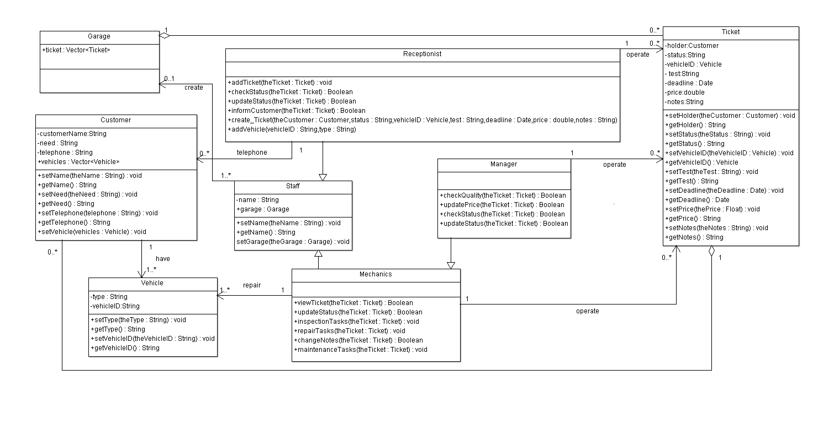

**Task 5**

Produce a UML activity diagram capturing the workflow of the garage

Answer:

